Акостакіоає Флоріан 414 КН

Білет 9

1. 2) Group by
2. 1) CREATE TRIGGER
3. 4) Виведуться всі записи з таблиці my_table
4. 4) Для управління користувачами
5. 2) Впорядковує записи по зростанню
6. 3)1)4)
7. 2) Постійно зберігає вибірку даних
8. 3)
9. 3)
10. 1) 3) 5)
11. 3) 4) 5) 6)

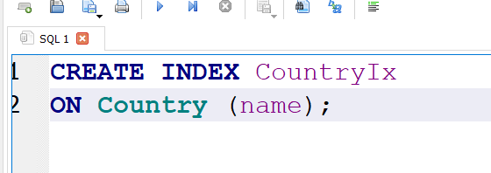

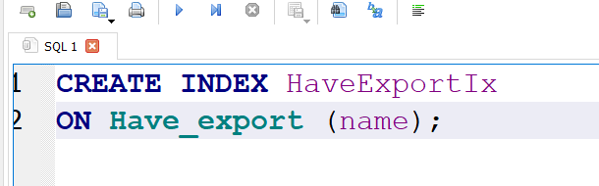

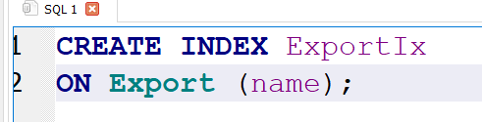

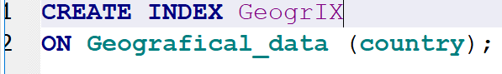

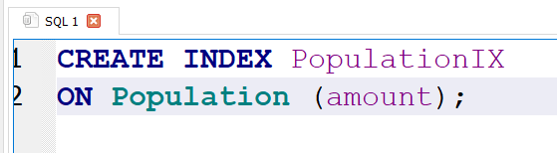

17. 1

SELECT

Country.name,

Geografical_data.area

FROM Country INNER JOIN Geografical_data

ON Geografical_data.country = Country.name

WHERE Country.name IN

(

SELECT Have_export.country

FROM Have_export

WHERE Have_export.name LIKE "%metal%" OR

Have_export.name LIKE "%himia%"

)

17. 2

SELECT

Country.name

FROM Country INNER JOIN Have_export

ON Country.name = Have_export.country

WHERE Country.continennt != "Africa" AND Have_export.name = "coffe"

17. 3

SELECT

Country.name

FROM Country INNER JOIN Have_export

ON Country.name = Have_export.country

WHERE Country.continennt = "Eurasia" AND Have_export.name = "wood"

18. 1

CREATE VIEW "CG_prod" AS

SELECT

Country.name

FROM Country INNER JOIN Have_export

ON Country.name = Have_export.country

WHERE Have_export.name NOT LIKE "%CG_prod%"

18. 2

CREATE VIEW "ExportGoods" AS

SELECT

Country.name,

COUNT(Have_export.country)

FROM Country INNER JOIN Have_export

ON Country.name = Have_export.country

GROUP BY Country.name

18. 3

CREATE VIEW AvgAfrica AS

SELECT

Country.name,

AVG(Population.VVP)

FROM Country INNER JOIN Population

ON Country.name = Population.country

GROUP BY Country.name

HAVING Country.name = "Africa"

19. 1

SELECT

(

SELECT AVG(VVP) FROM Population

INNER JOIN Country ON

Population.country = Country.name

WHERE Country.continennt = "Eurasia"

) AS AveragePerEurasia,

Country.name

FROM Country INNER JOIN Population

ON Country.name = Population.country

WHERE Country.continennt = "Eurasia" AND Population.VVP < AveragePerEurasia

19 . 2

SELECT

(

SELECT AVG(VVP) FROM Population

) AS AveragePerWorld,

Country.name

FROM Country INNER JOIN Population

ON Country.name = Population.country

WHERE Population.VVP > AveragePerWorld

19. 3

SELECT

Have_export.name

FROM Have_export

WHERE Have_export.country IN

(

SELECT

Country.name

FROM Country INNER JOIN Geografical_data

ON country.name = Geografical_data.country

WHERE Geografical_data.area < 1000000

)

BEGIN TRANSACTION;

INSERT INTO Economical_data

(money) VALUES ("grivna");

INSERT INTO Languages

(language) VALUES ("Uknrainian");

INSERT INTO Relief

(relief) VALUES ("Good relief I like it");

INSERT INTO Export

(name) VALUES ("Some salo");

DELETE FROM Export

WHERE name = "Some salo";

UPDATE Country

SET second_city = "Chernivtsy"

WHERE Country.name = "Ukraine";

COMMIT;

BEGIN TRANSACTION;

CREATE TABLE "Country"

(

"name" VARCHAR NOT NULL,

"money" VARCHAR NOT NULL,

"government_type" VARCHAR NOT NULL,

"capital" VARCHAR NOT NULL,

"second_city" VARCHAR,

"continennt" VARCHAR NOT NULL,

FOREIGN KEY (money) REFERENCES Economical_data(money)

ON DELETE CASCADE ON UPDATE CASCADE,

FOREIGN KEY (government_type) REFERENCES Political_data(government_type)

ON DELETE CASCADE ON UPDATE CASCADE,

FOREIGN KEY (continennt) REFERENCES Continent(name)

ON DELETE CASCADE ON UPDATE CASCADE , PRIMARY KEY("name")

);

CREATE TABLE Have_relief ( relief VARCHAR NOT NULL, country VARCHAR NOT NULL, FOREIGN KEY (relief) REFERENCES Relief(relief) ON DELETE CASCADE ON UPDATE CASCADE, FOREIGN KEY (country) REFERENCES Country(name) ON DELETE CASCADE ON UPDATE CASCADE )

CREATE TABLE Languages ( language VARCHAR NOT NULL, PRIMARY KEY("language") )

CREATE TABLE Political_data ( government_type VARCHAR NOT NULL, PRIMARY KEY("government_type") )

CREATE TABLE Population ( amount INT NOT NULL, VVP VARCHAR NOT NULL, specialty VARCHAR NOT NULL, country VARCHAR NOT NULL, FOREIGN KEY (country) REFERENCES Country(name) ON DELETE CASCADE ON UPDATE CASCADE )

CREATE TABLE Relief ( relief TEXT, PRIMARY KEY("relief") )

COMMIT;